Discuss Example 7.13
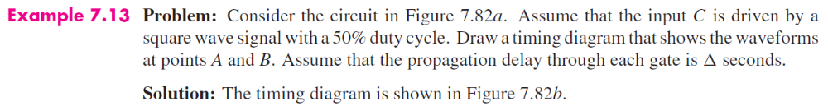

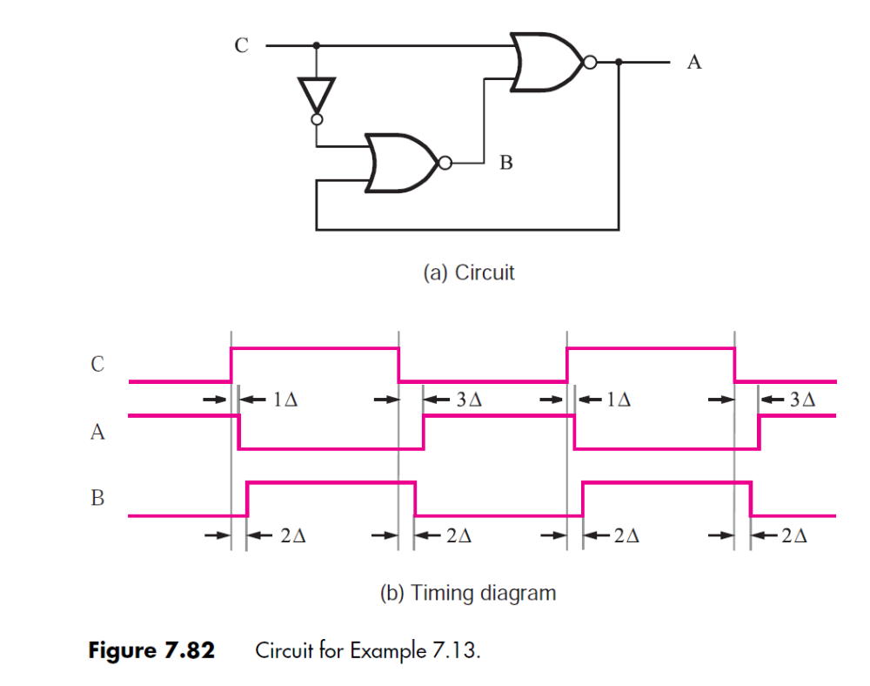

7.1
Question:

Solution:
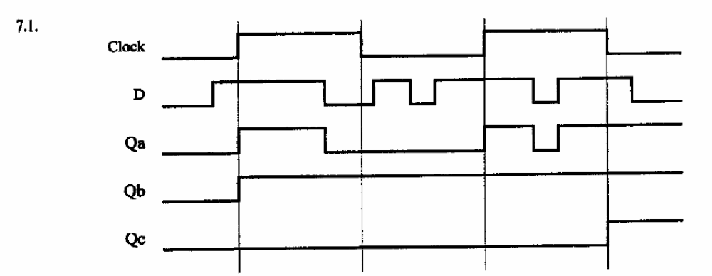

7.3
Question:

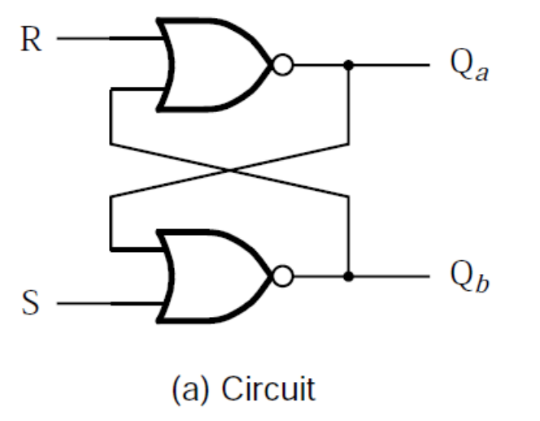

Solution:
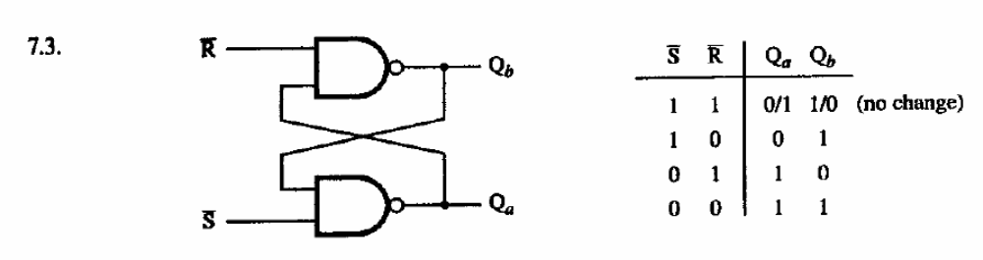

7.5
Question:

Solution:
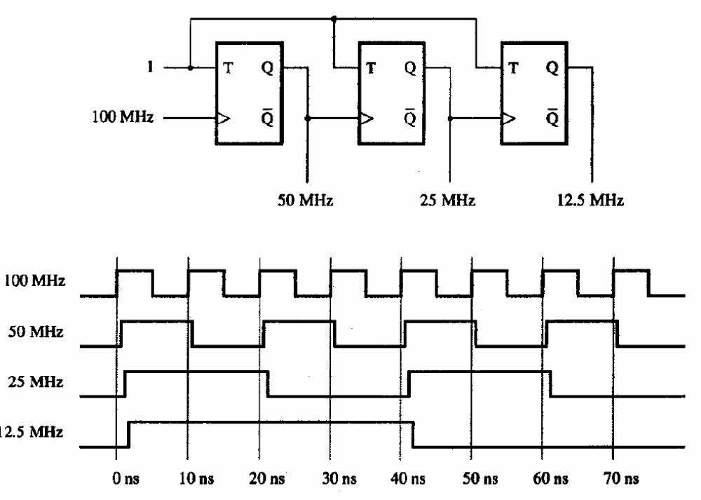

7.6 - discuss the provided solution: derive an alternate answer using exactly the same gates; which is best?
Question:

Solution 1:
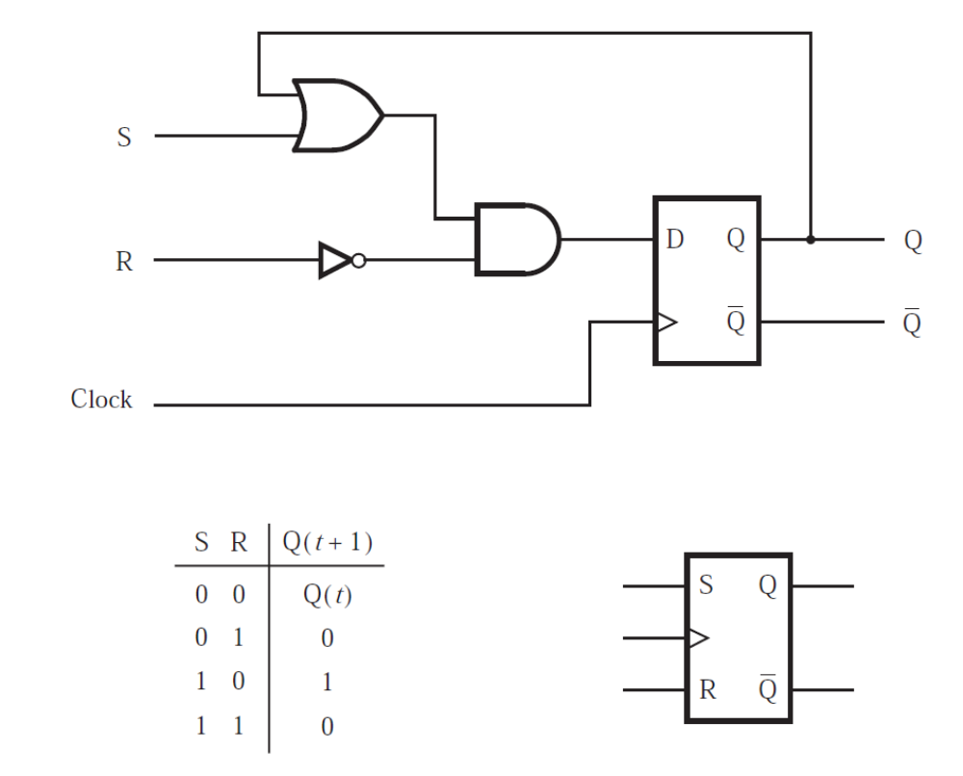

Solution 2:
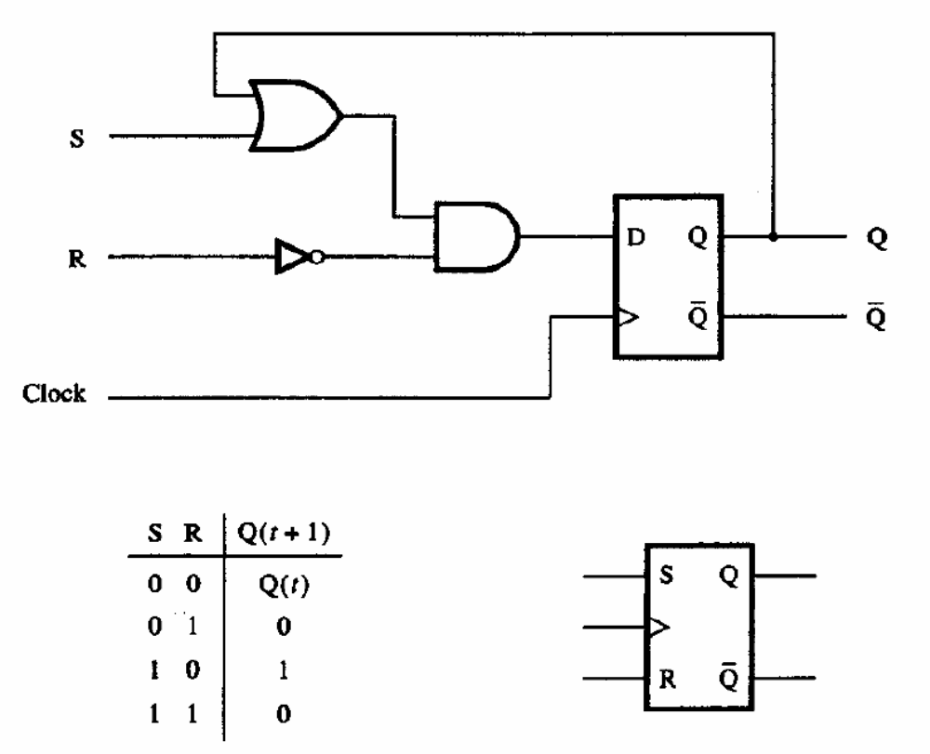

7.8
Consider the following VHDL code:
PROCESS (Resetn, Clk)
BEGIN
IF Resetn = '0' THEN
Q <= '0';
ELSIF Clk'EVENT AND Clk = '1' THEN
Q <= D;
END IF;
END PROCESS;

Assume Resetn transitions from '0'?'1' (low to high) while the Clk signal is '1' (high).
What is the value of Q at this instant?
What would the value of Q become if, before the Clk signal goes low, the D signal transitions from '0'?'1'?
If the ELSIF clause were written as "ELSIF Clk = '1' THEN" instead of "ELSIF Clk'EVENT AND Clk = '1' THEN", what would the value of Q be after each of the scenarios described in a. and b. above?

